Alexandra Nelander, Mariana Peredo, Daniel Aquino Okeke, Lian Salah
November 2, 2021
FSE 100 T TH 3:00
Project Spyn Milestone 3- Navigation
Robot Photo:

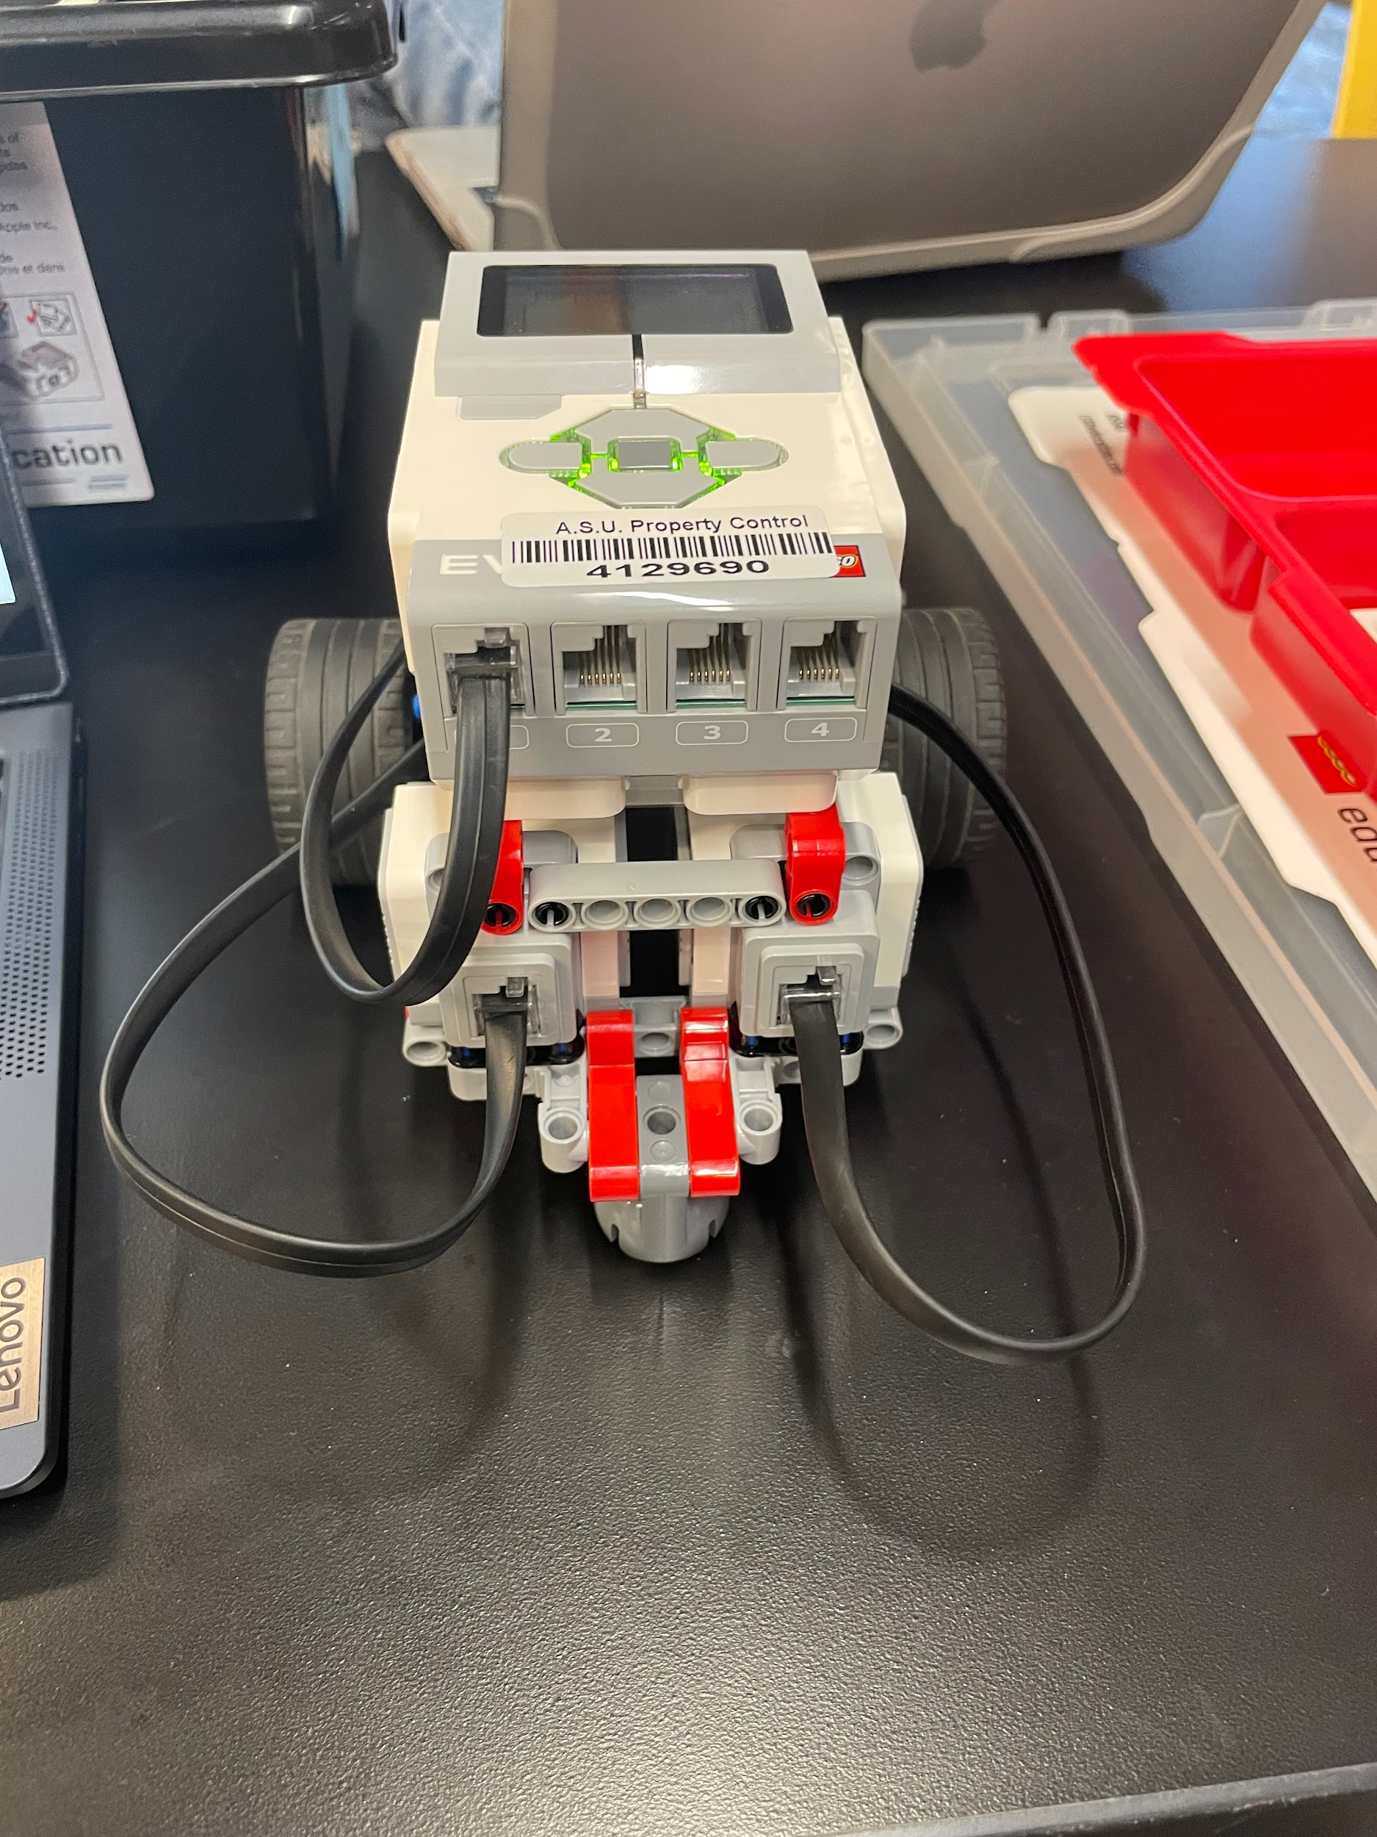

MATLAB Code:

brick.SetColorMode(1, 2);
color = brick.ColorCode(1);

global key;
InitKeyboard();

while 1
pause(0.1);
switch key
case 'uparrow'
disp('Up Arrow Pressed!')
brick.MoveMotor('C', 50);
brick.MoveMotor('B', 50);
pause(1);
brick.StopMotor('B');
brick.StopMotor('C');
case 'downarrow'
disp('Down Arrow Pressed!')
brick.MoveMotor('C', -50);
brick.MoveMotor('B', -50);
pause(1);
brick.StopMotor('B');
brick.StopMotor('C');
case 'rightarrow'
disp('Right Arrow Pressed!')
brick.MoveMotor('C', 50);
pause(1);
brick.StopMotor('C');
case 'leftarrow'
disp('Left Arrow Pressed!')
brick.MoveMotor('B', 50);
pause(1);
brick.StopMotor('B');
case 'q'
disp('End Program!')
break;
end
end

CloseKeyboard();

if (color == 2)
brick.MoveMotor('A', 50);
elseif (color == 3)
brick.MoveMotor('A', -50);
elseif (color == 5)
brick.StopMotor('B');
brick.StopMotor('C');
pause(4);
end

YouTube Video:
https://youtu.be/kssYBoT93DU

